**MIDDLETON CHENEY FOOTBALL CLUB**

**ANNUAL GENERAL MEETING**

**1985**

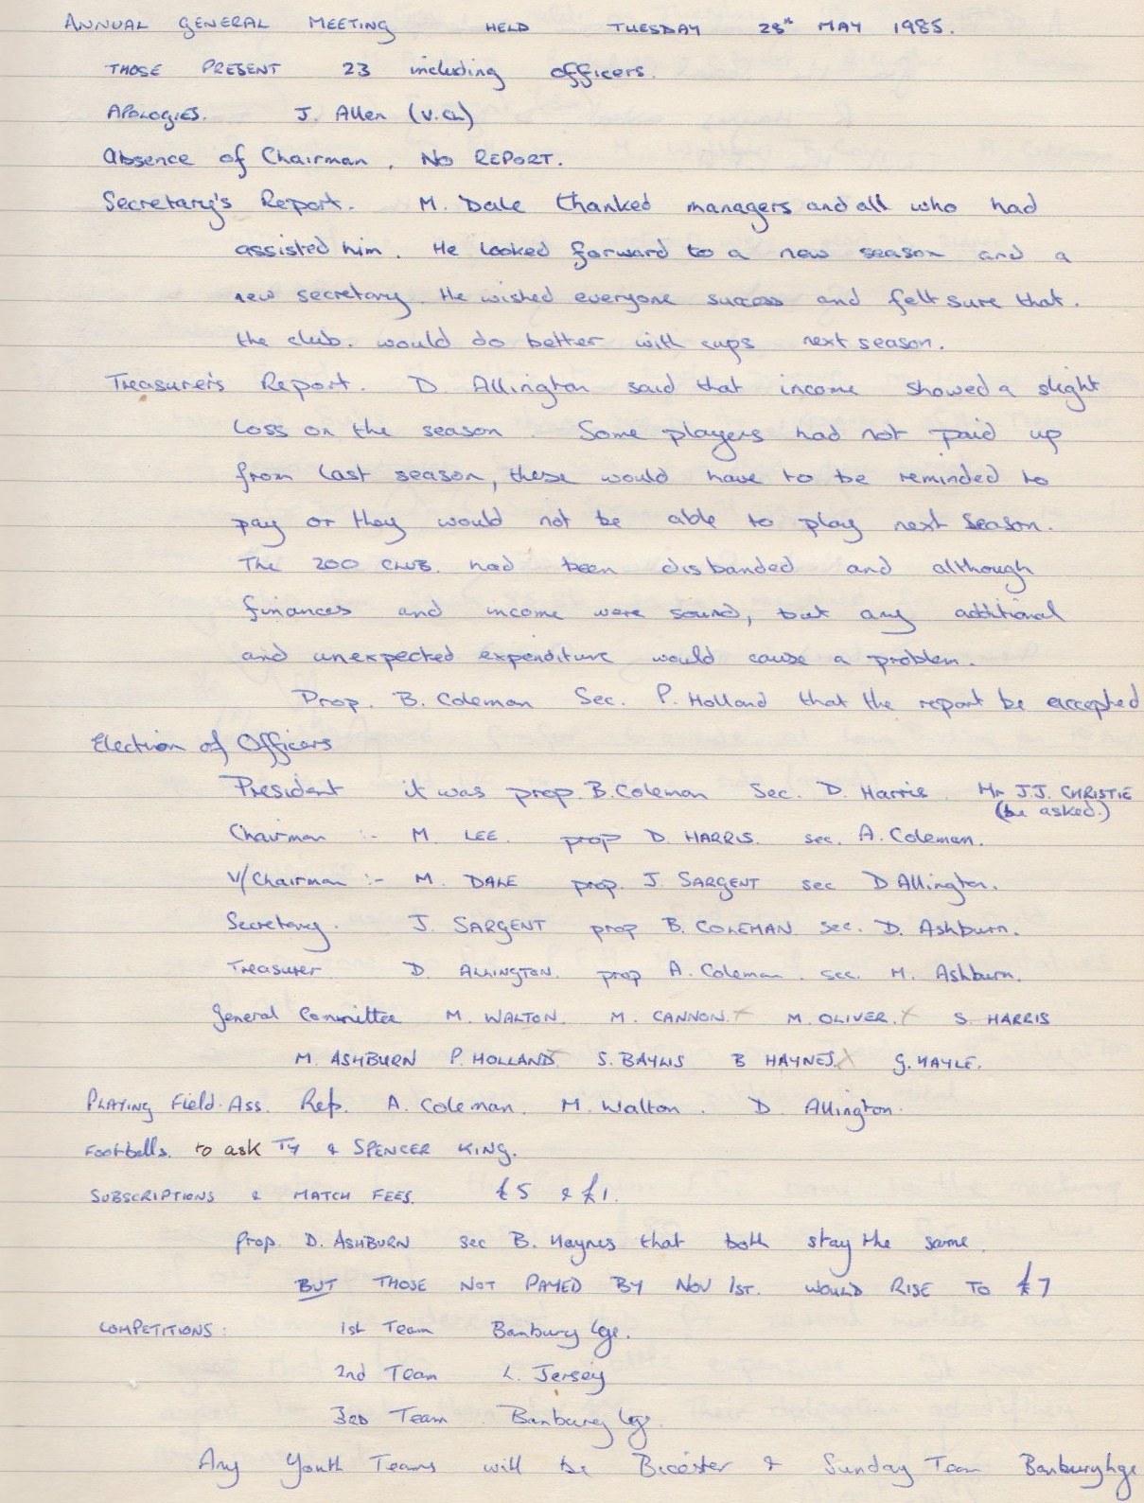

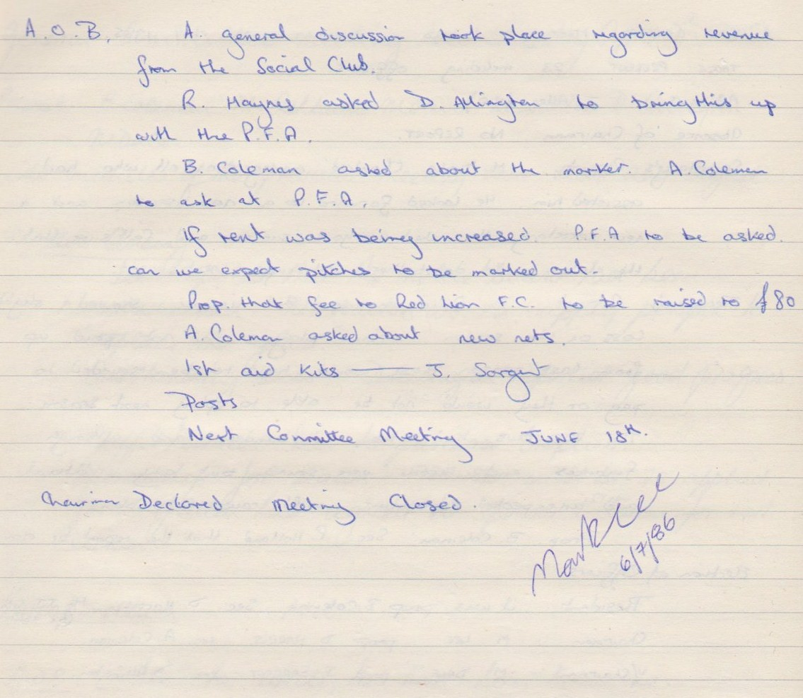

**General Committee Meeting**

**June 18th 1985**

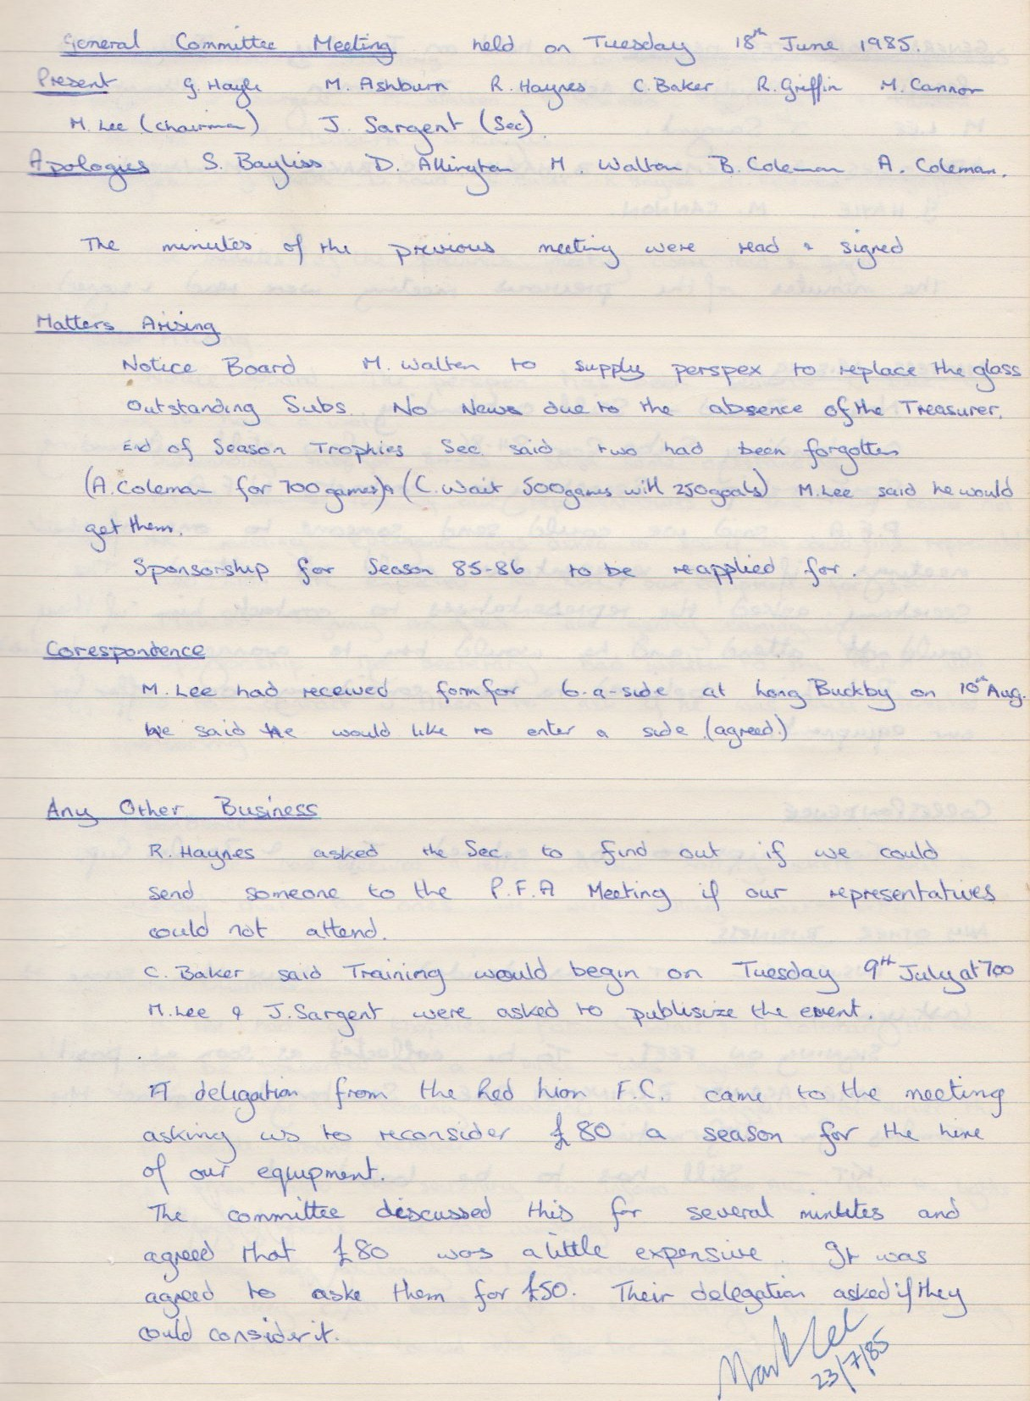

**General Committee Meeting**

**July 23rd 1985**

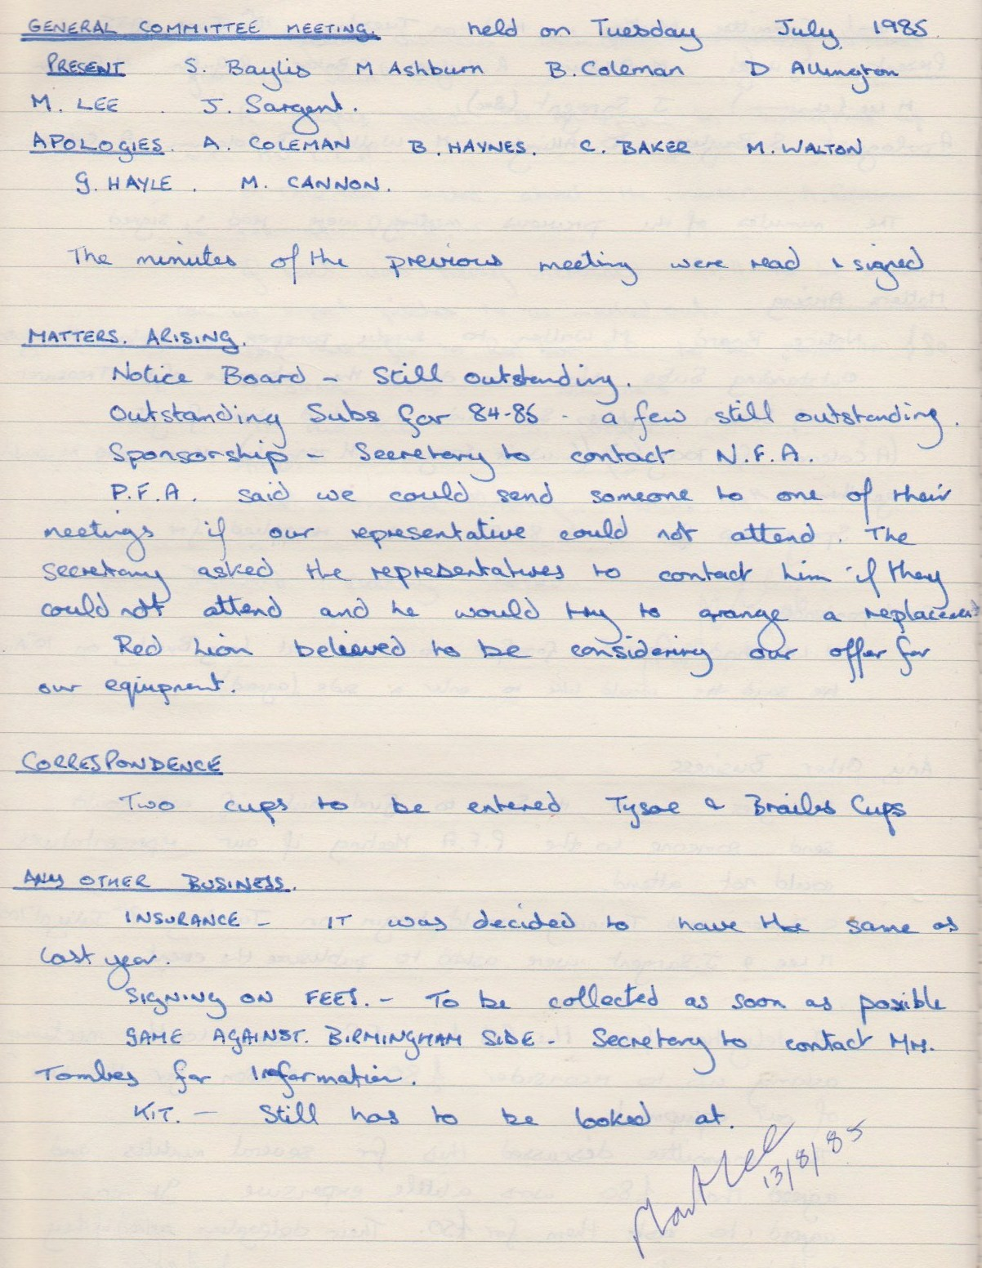

**General Committee Meeting**

**August 13th 1985**

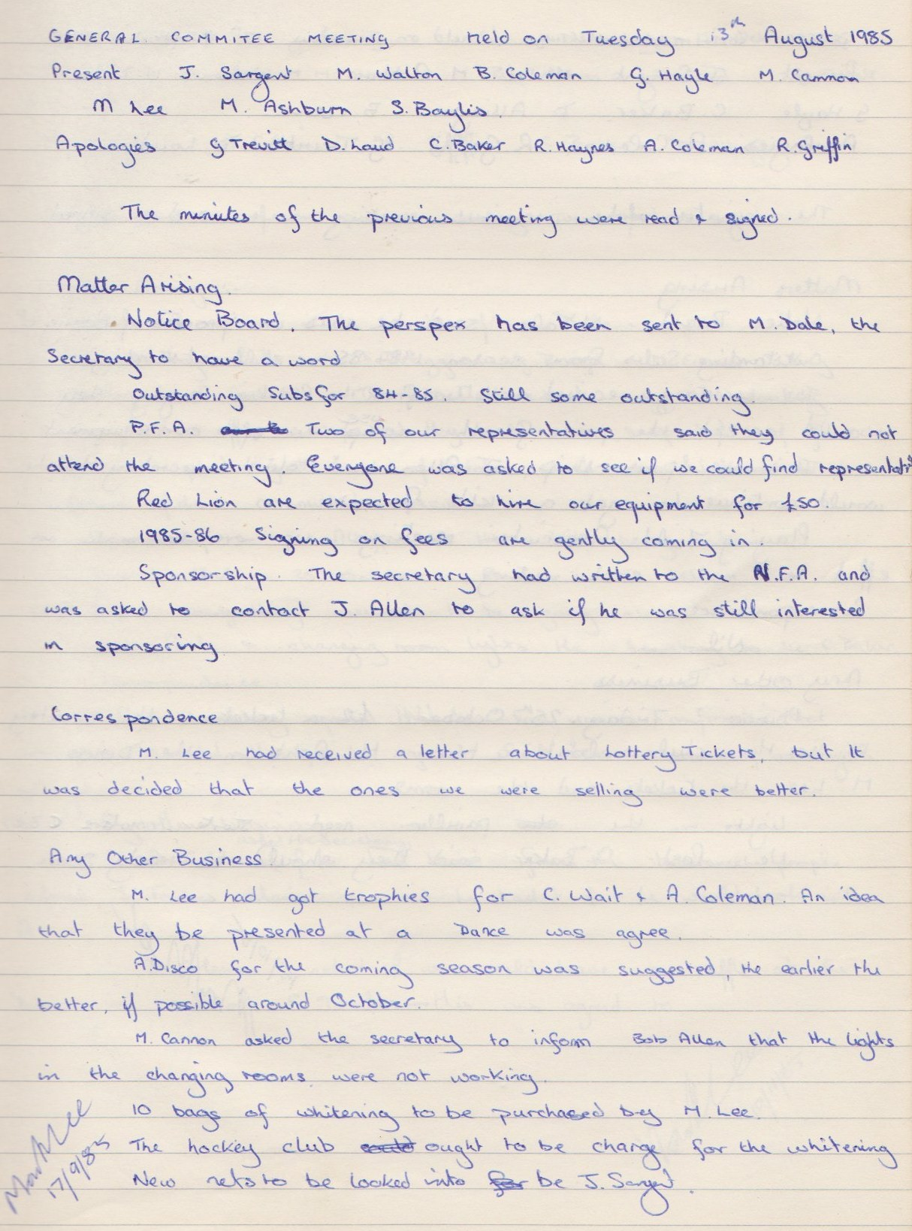

**General Committee Meeting**

**September 17th 1985**

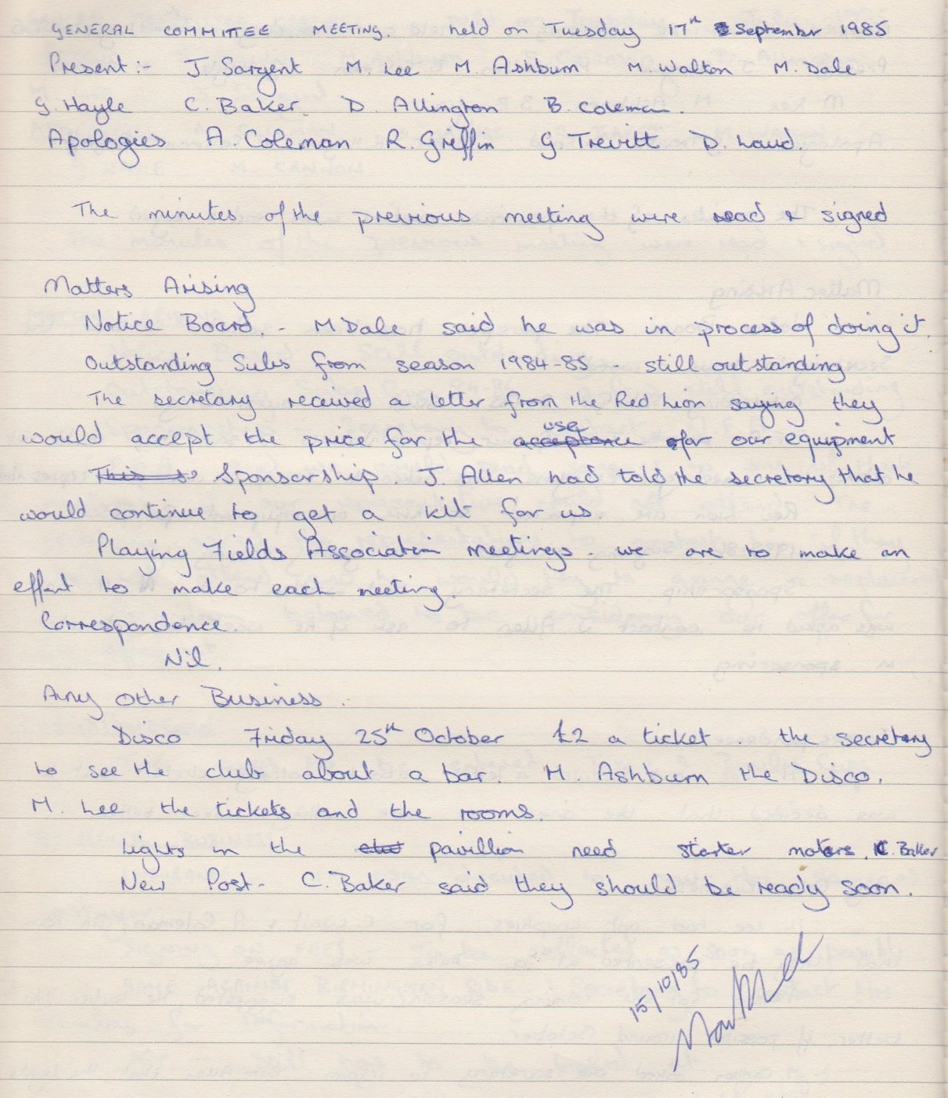

**General Committee Meeting**

**October 15th 1985**

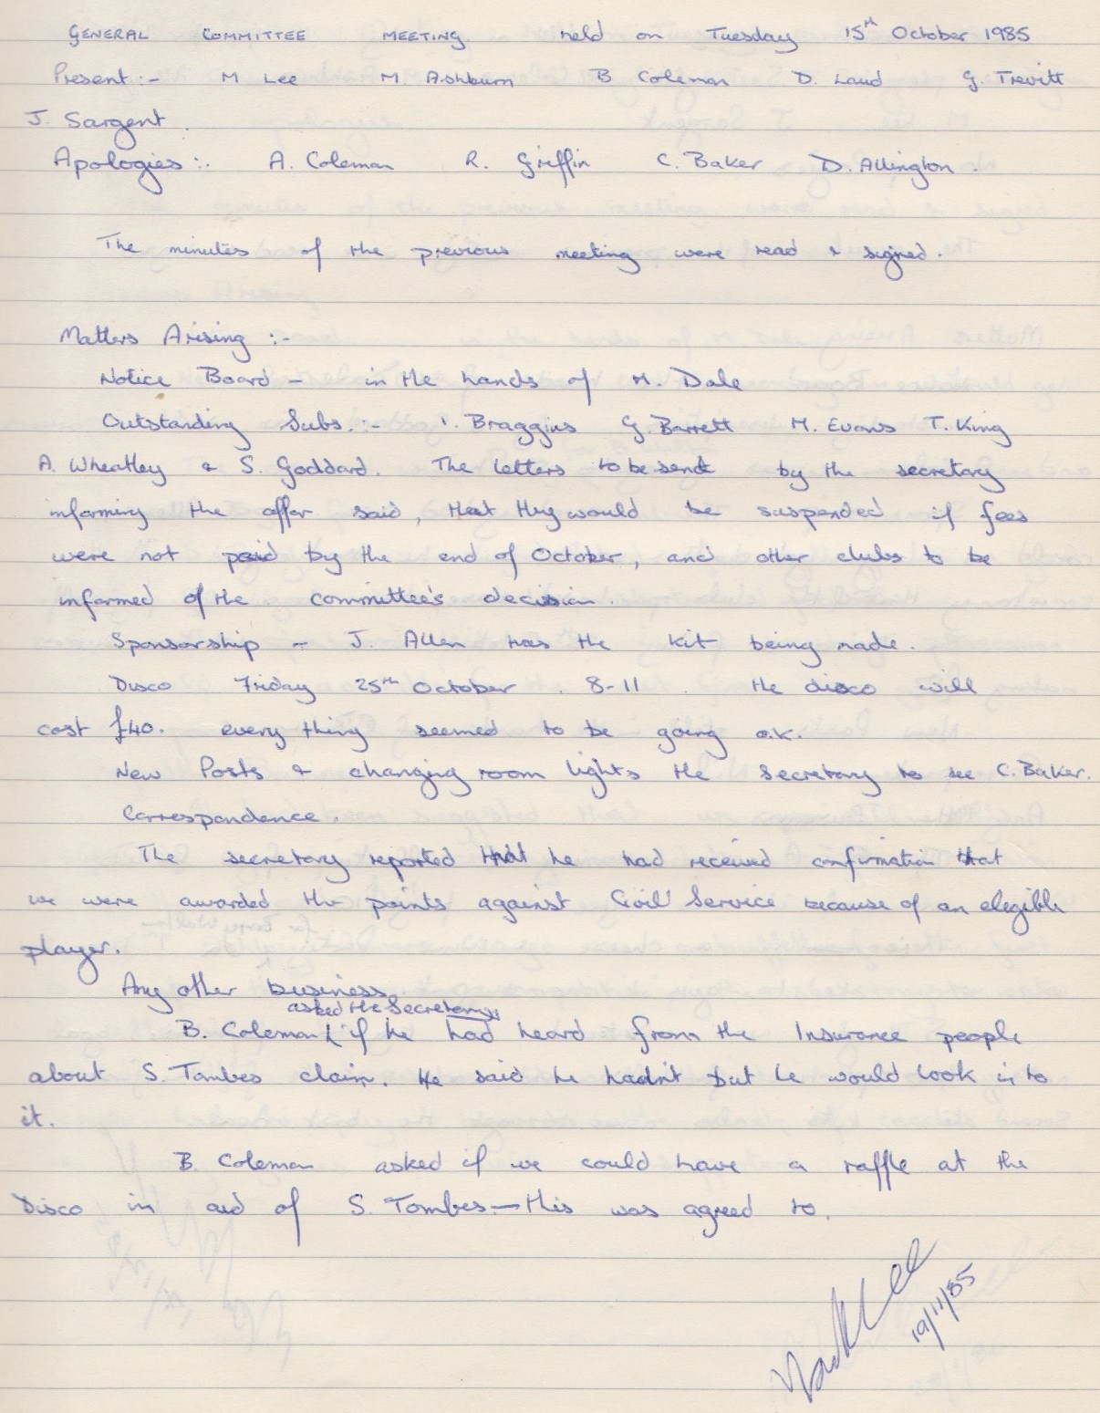

**General Committee Meeting**

**November 19th 1985**

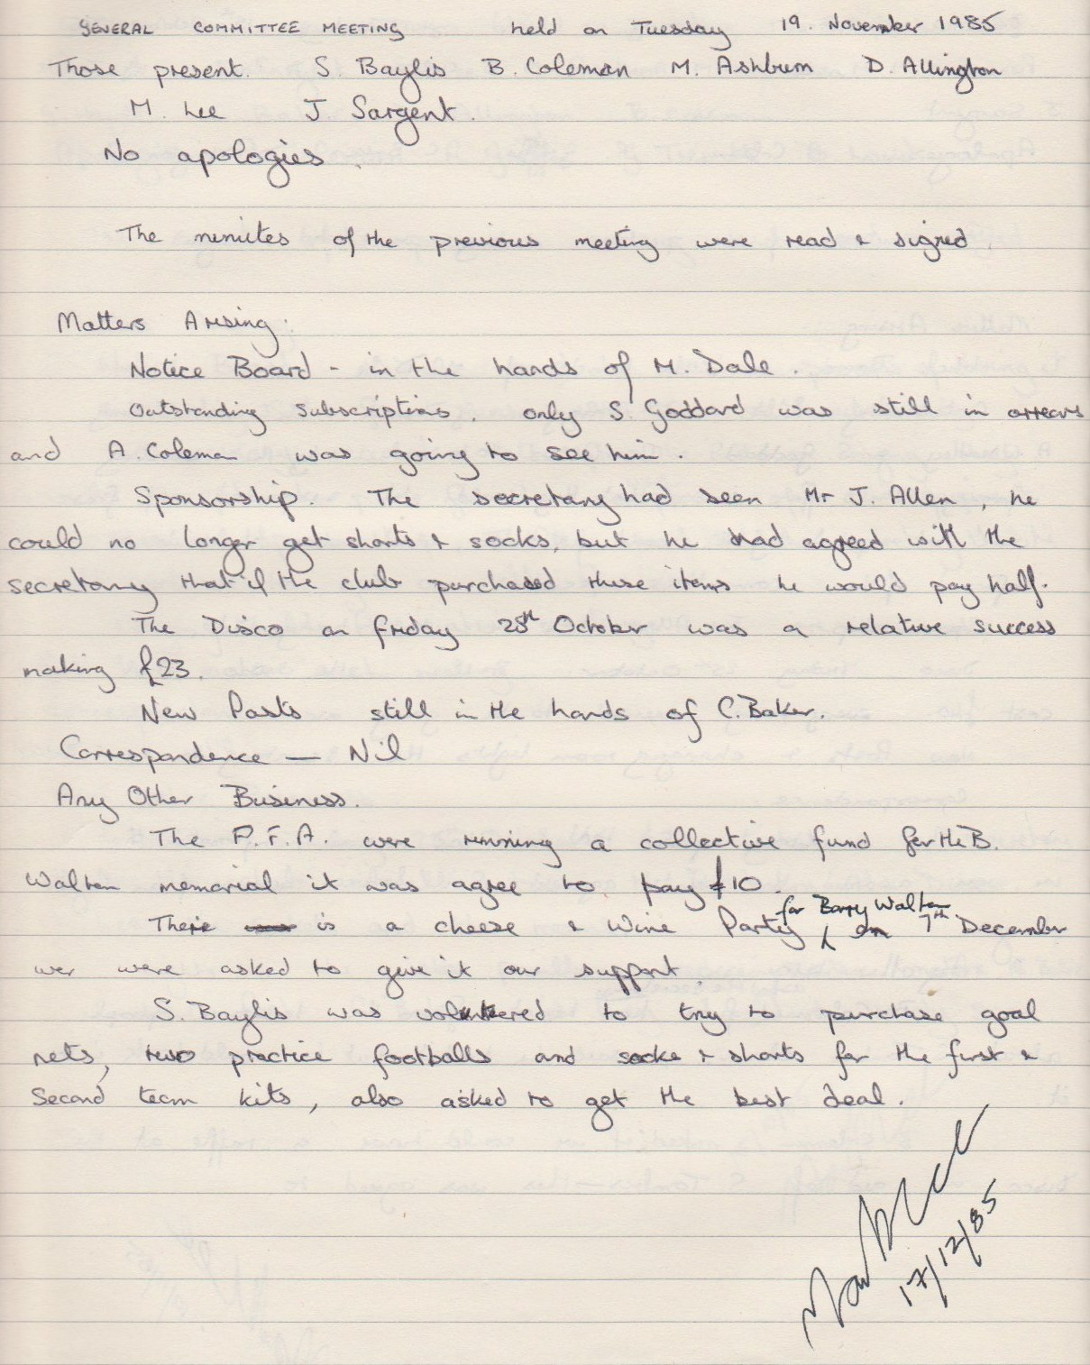

**General Committee Meeting**

**December 17th 1985**

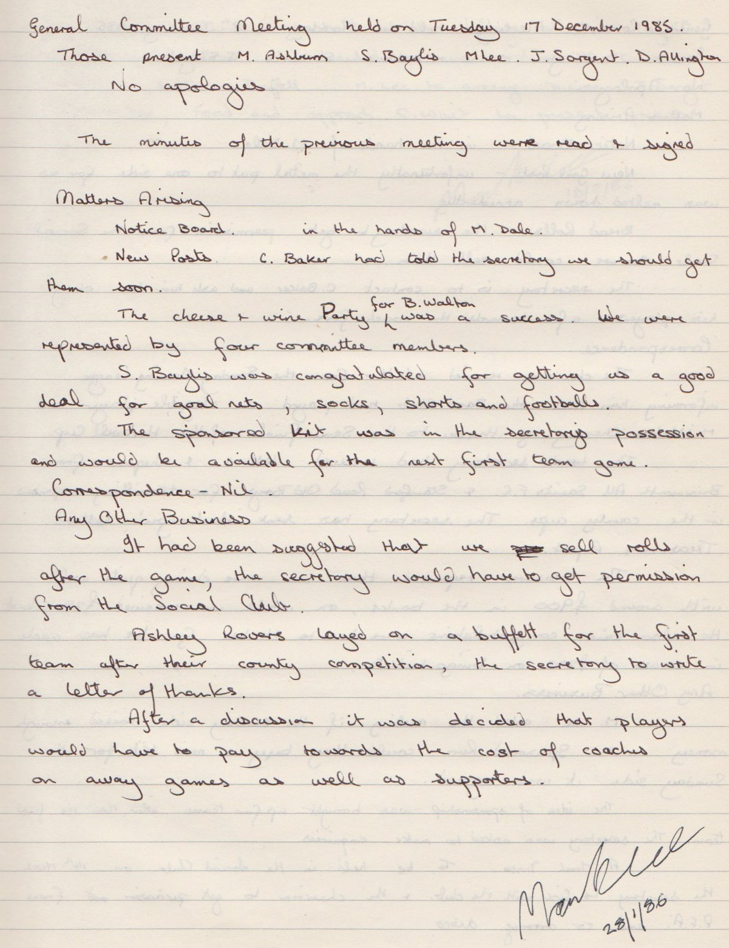

**General Committee Meeting**

**January 28th 1986**

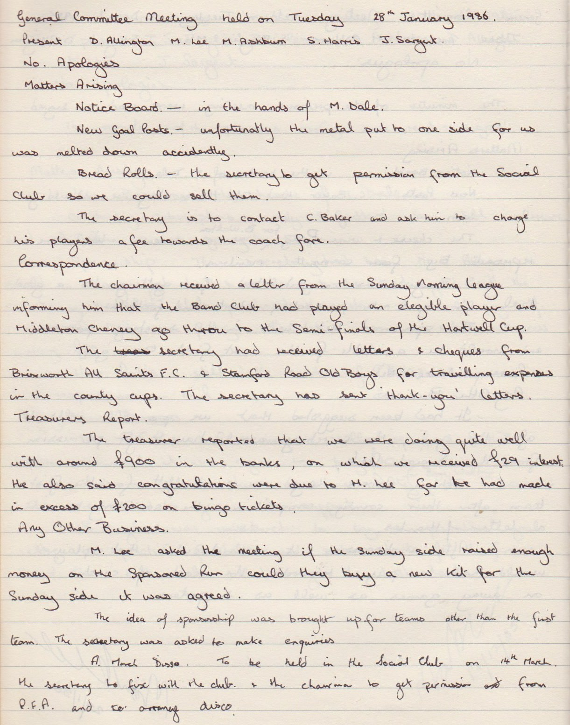

**Continued**

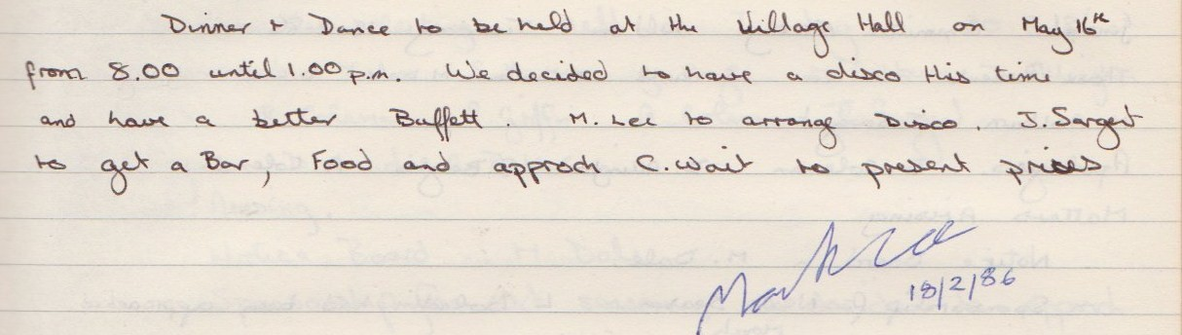

**General Committee Meeting**

**February 18th 1986**

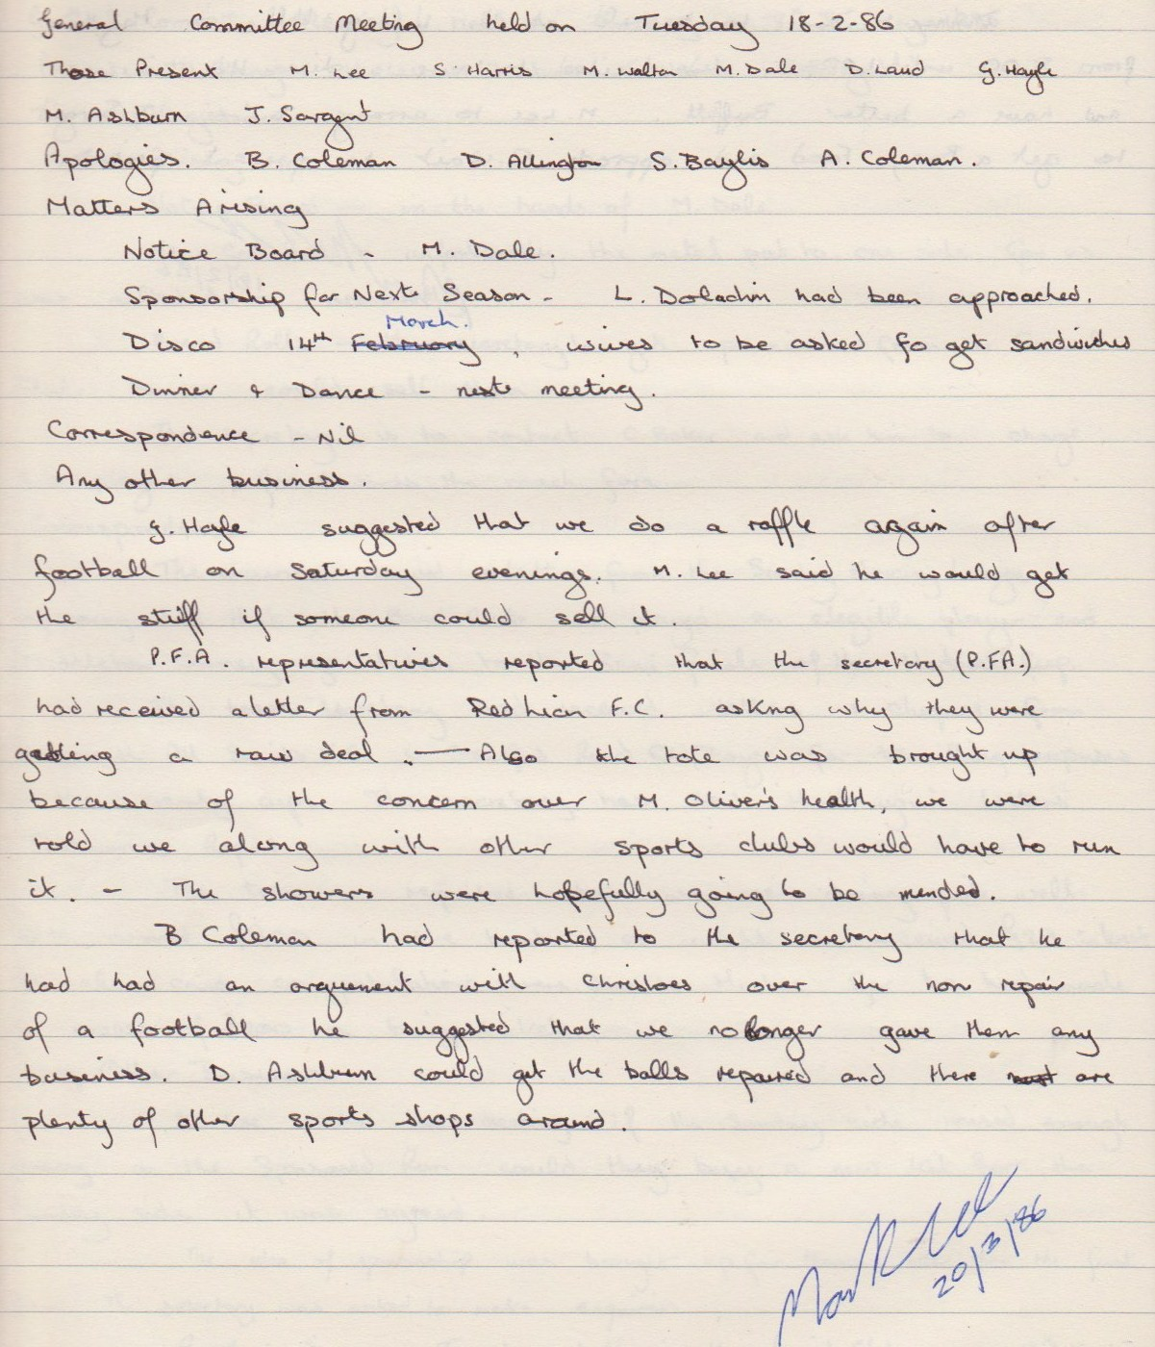

**General Committee Meeting**

**March 20th 1986**

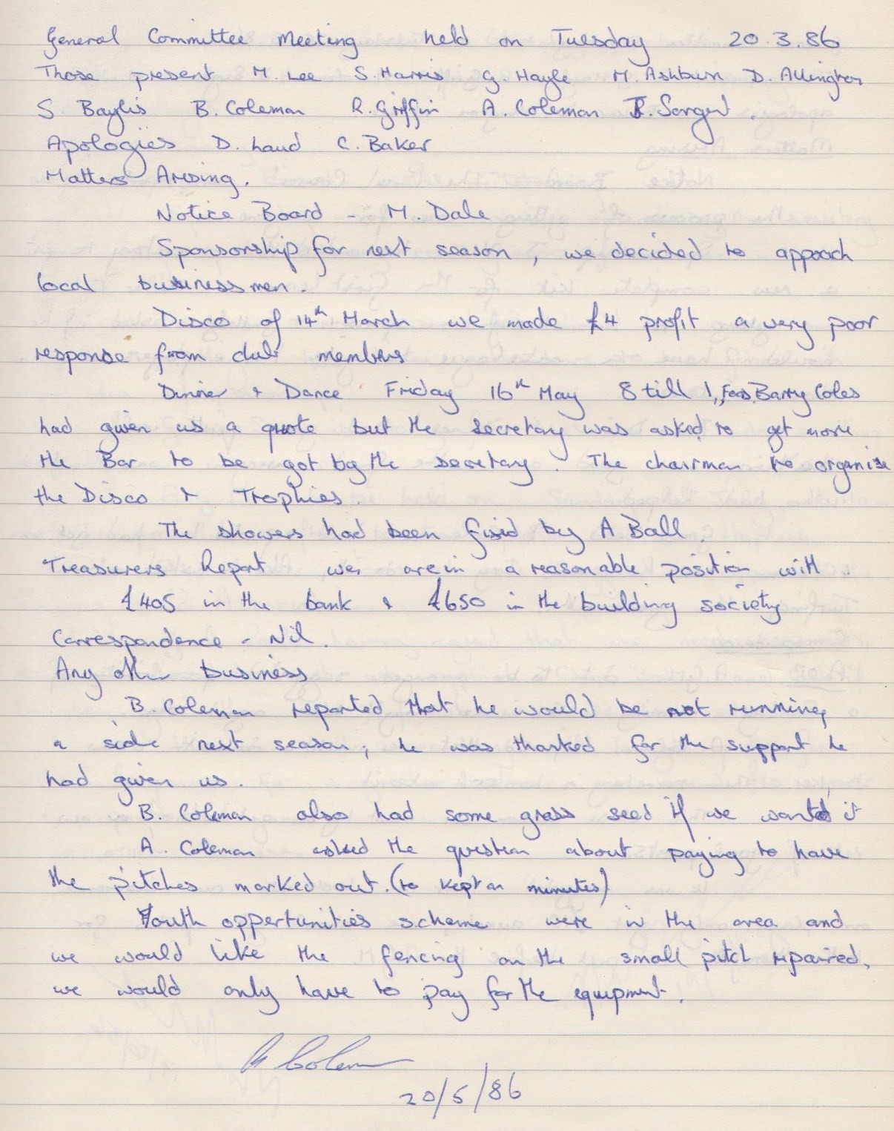

**General Committee Meeting**

**May 20th 1986**

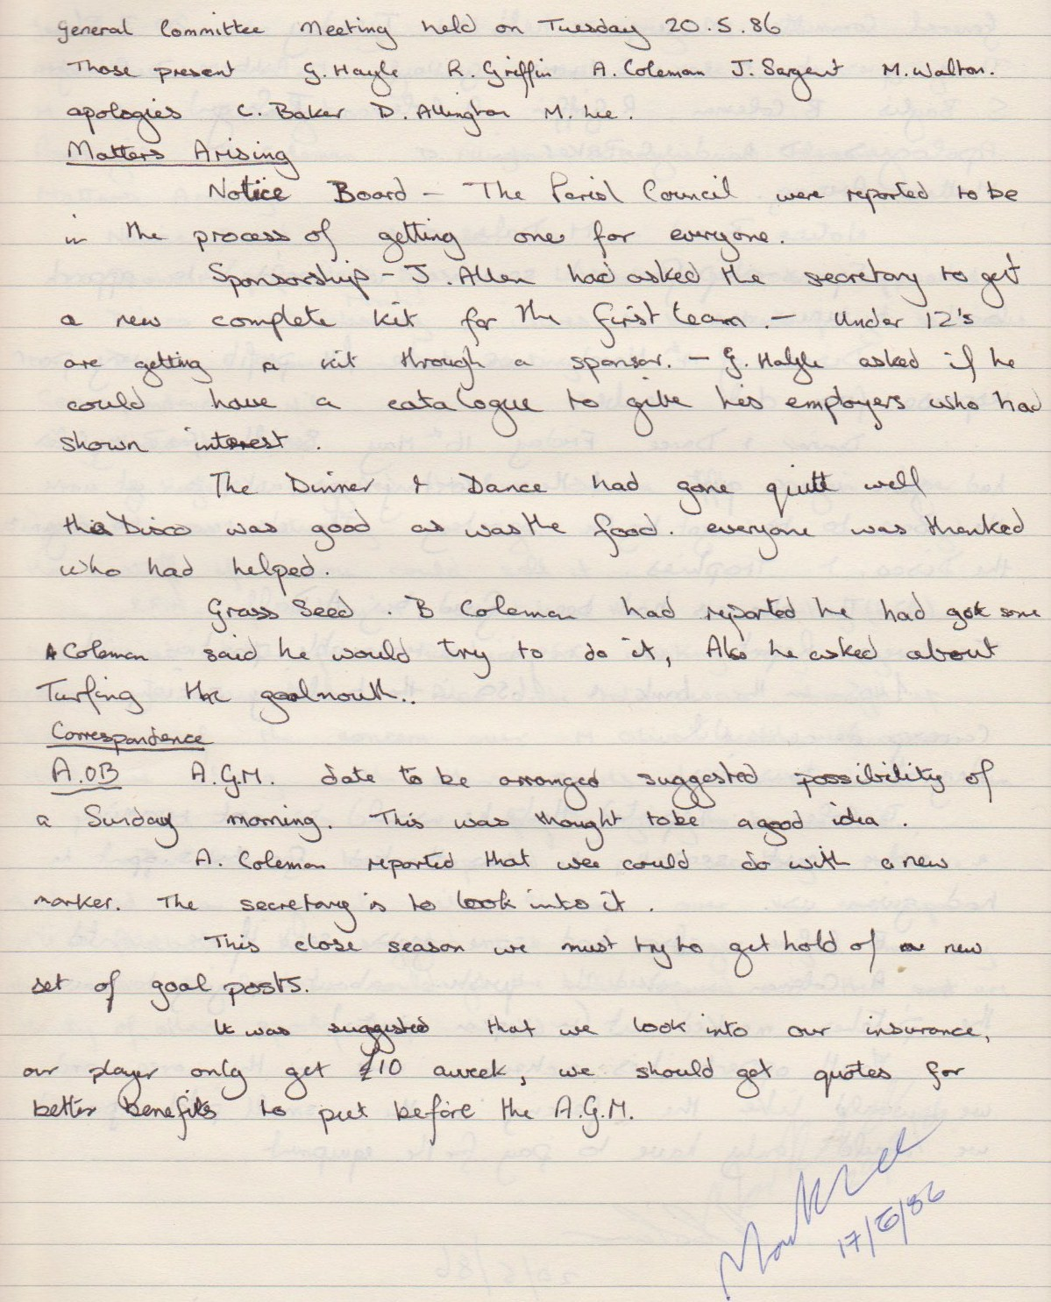

**General Committee Meeting**

**June 17th 1986**

